Retail Sales Analysis Report

1. Business Problem

The retail company needed insights into its sales and profit performance across regions, product categories. Specifically, the business faced challenges in:

- Identifying best-performing categories and regions.

- Tracking monthly sales trends to support forecasting.

- Measuring overall KPIs: Total Sales, Total Profit and Profit Margin %.

- Analyse Seasonality Trend to improve production.

2. Data Cleaning Steps

To prepare the dataset, the following steps were taken in Power Query/Excel:

- Removed blanks and irrelevant fields (cleaned Order ID, removed unwanted fields).

- Standardized column names (e.g., "Prod_Category" → "Product Category").

- Adjusted data types – ensured correct formats for Date, Numbers, and Percentage.

- Created calculated field: Profit Margin

- Profit Margin = Profit / Sales

- Replaced the Yes/No with returned/not returned.

- Created PivotTables (in tables) and linked to Dashboard visuals.

3. Key Questions & Answers

Q1. Which region had best overall performance?

- East region had best performance

- Central and west had the lower performance

Q2. What is the sales trend over months in each region?

- Sales peak in March–April.

Q3. Which is the most returned and not returned?

- The most returned product is chairs.

- The least returned product is tables.

Q4. What are the overall KPIs?

- Total Sales: ₹3,29,638

- Total Profit: ₹58,793

- Profit Margin: 17%

4. Dashboard Screenshots

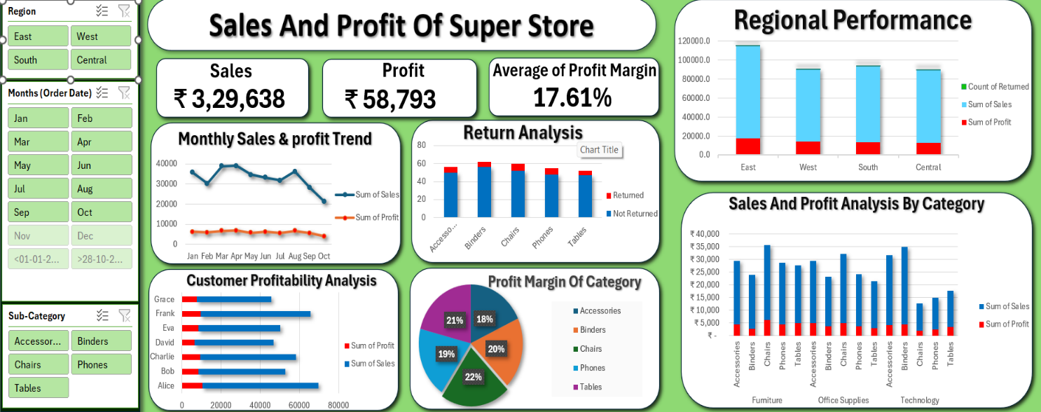

- KPI cards (Sales, Profit, Profit Margin).

- Sales by Region/Category chart.

- Monthly Sales Trend line chart.

- Return analysis.

5. Recommendations

- Optimize Discount Policy → Cap discounts at 15%, as higher cuts damage profit margins.

- Regional Strategy → Allocate more resources to high-performing regions; explore why some regions underperform.

- Seasonal Readiness → Prepare inventory and marketing campaigns ahead of March-April sales peak.

- Continuous Monitoring → Refresh the dashboard monthly to track progress and adjust strategies.

